**CUSTOMER(PHP) GUIDE**

* First, you need to go to the homepage of **Nature’s Fresh Mart** and then you can find the **LOGIN** button at the navigation bar

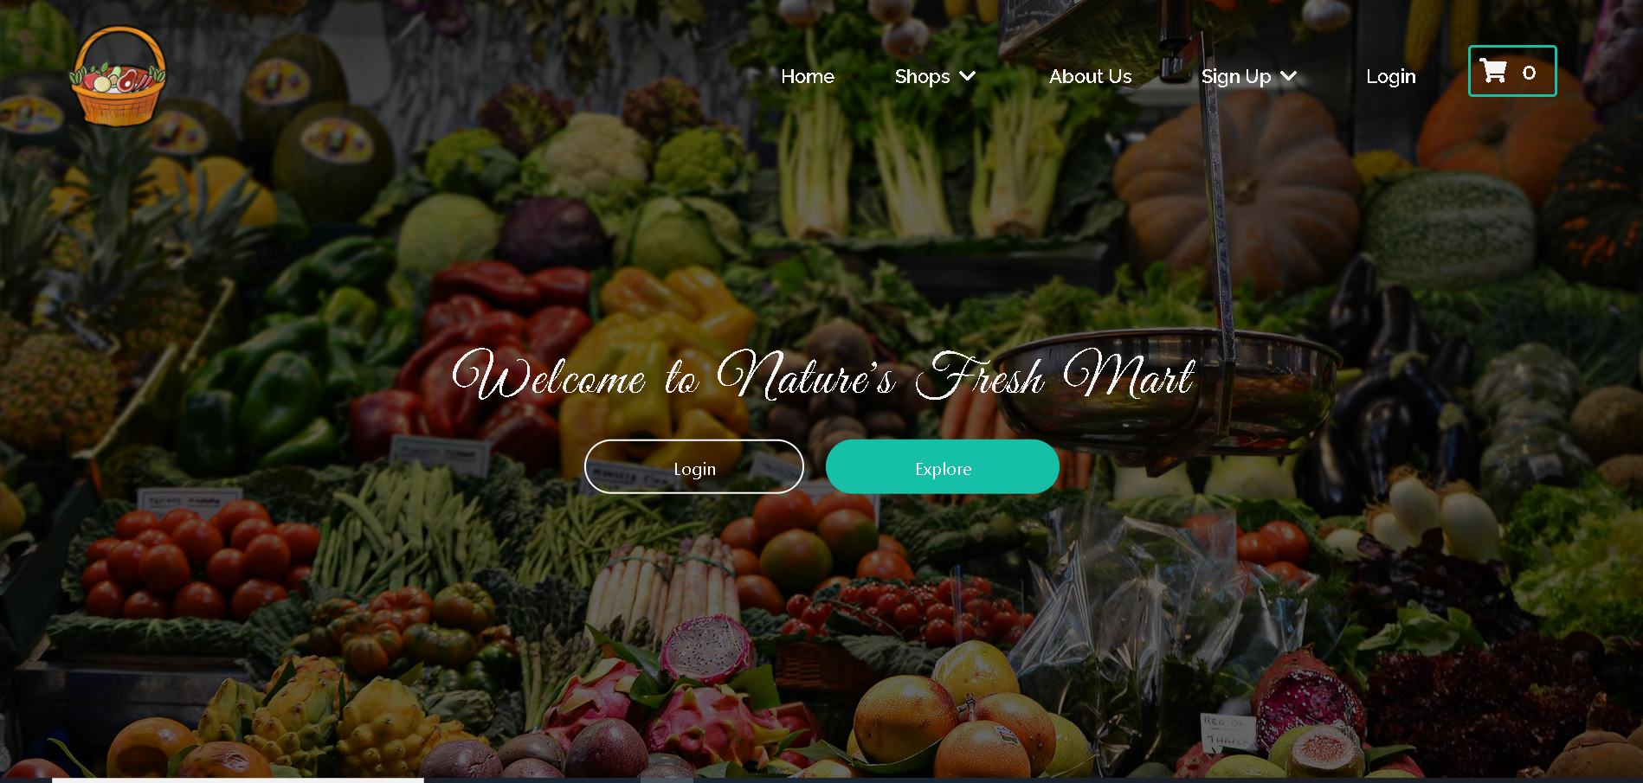

* Then, **login form** is displayed.

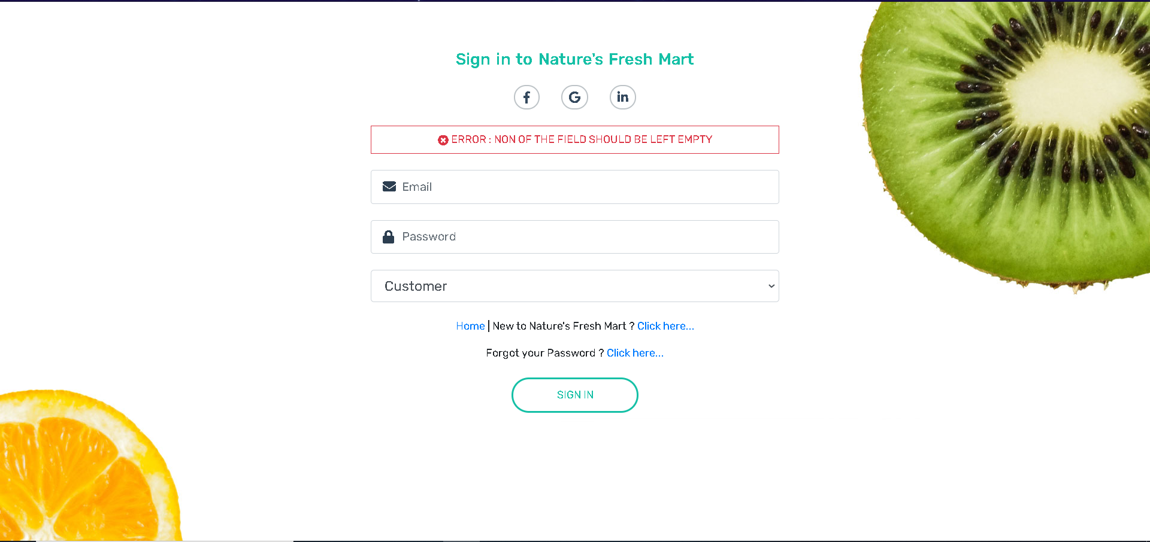

INVALID LOGIN

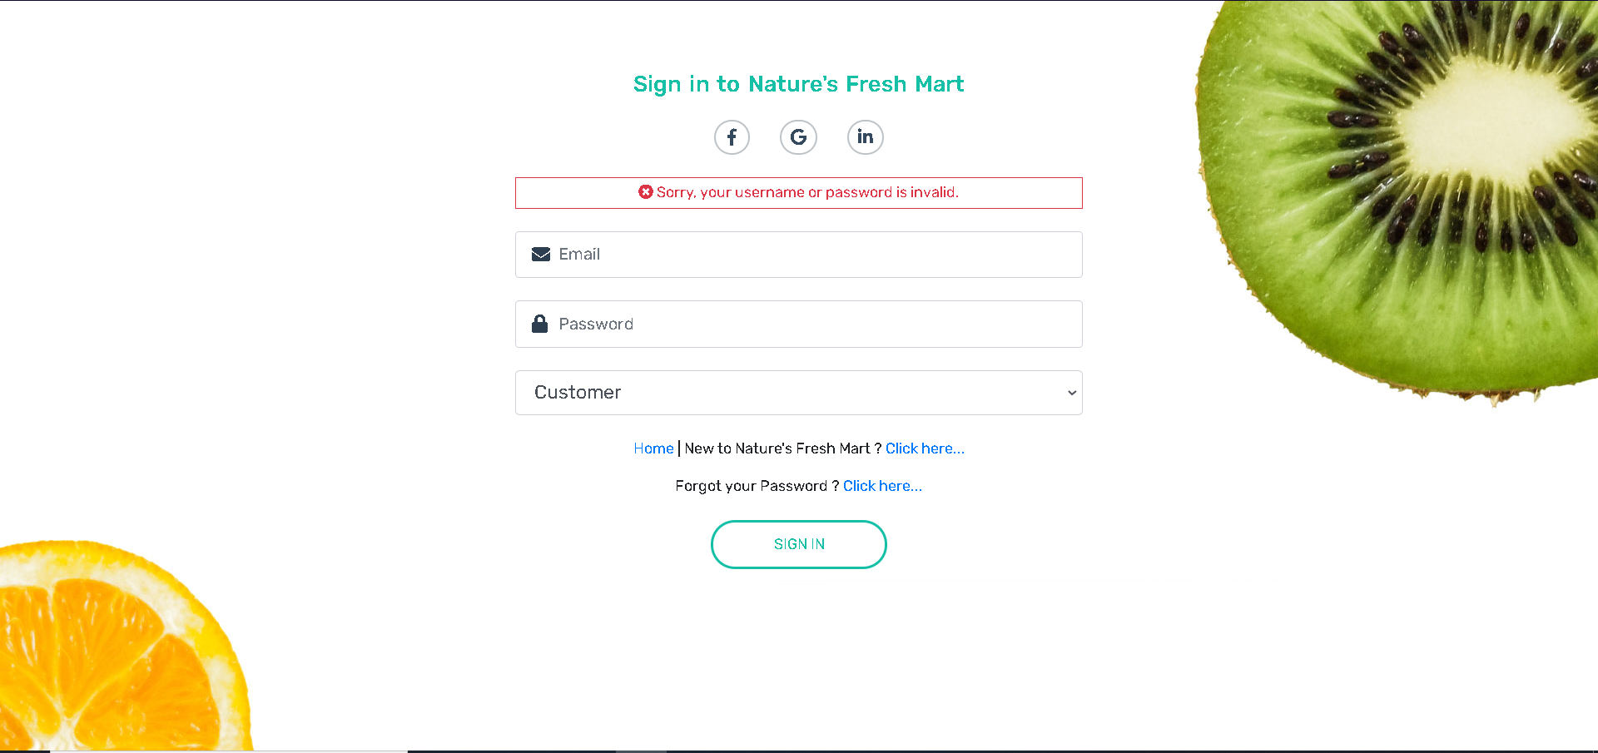

**Valid Login** Details user is redirected to homepage

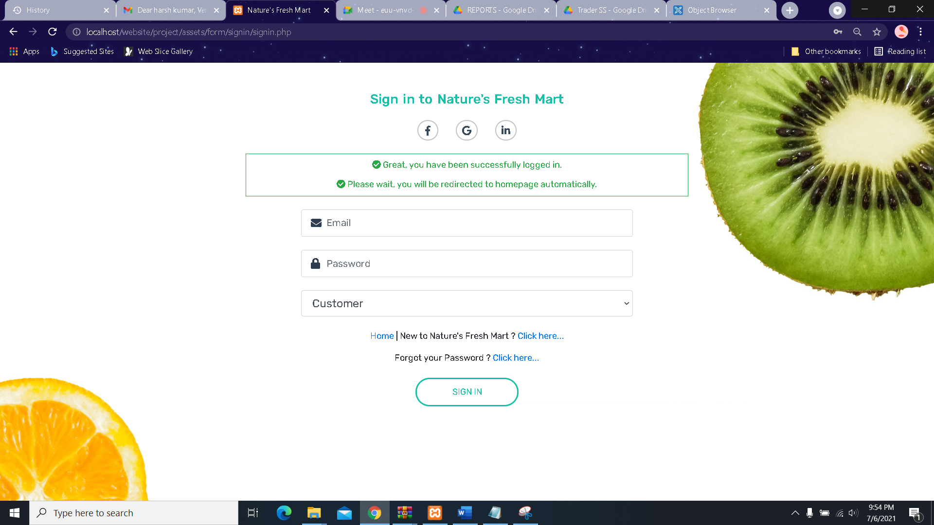

* If you aren’t already registered then you can do so by filling out the **sign-up form** which you can access directly by clicking the **Click here** link on the bottom of the login form or you can access it from the homepage also by clicking the sign-up dropdown menu in the homepage navbar

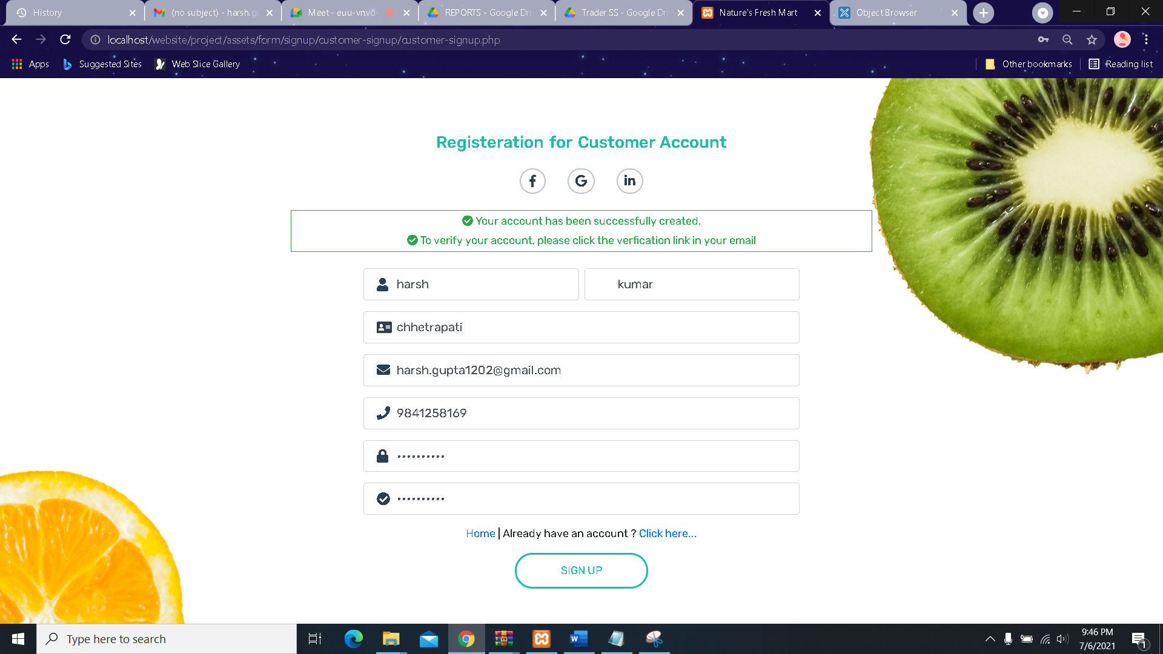

* After filling in the fields with valid information you’ll receive an email for verification. Inside the mail you'll also see a **Verify** button which needs to be clicked in order to verification process to take place.

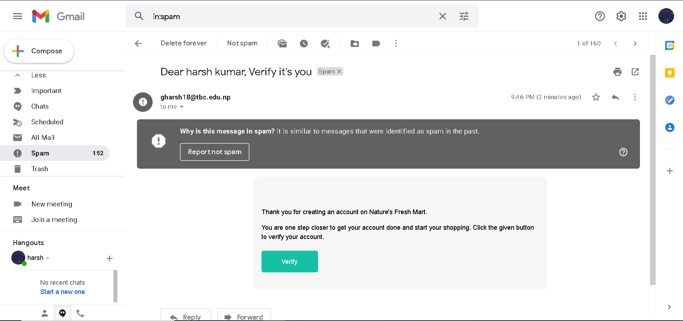

* After being verified you’ll be able to login as a customer in this website and your homepage will look the same but with an extra option in the navbar to access the Customer Panel.

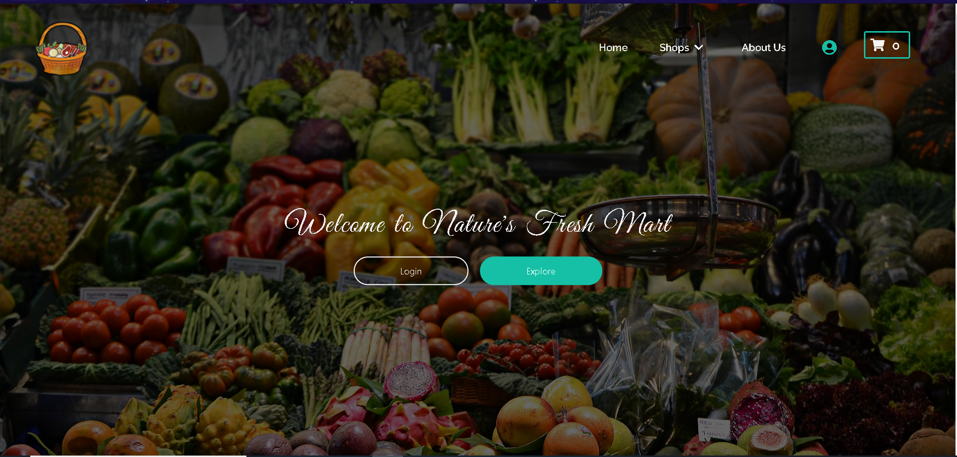

* You can also view **About Us** page which will look like this.

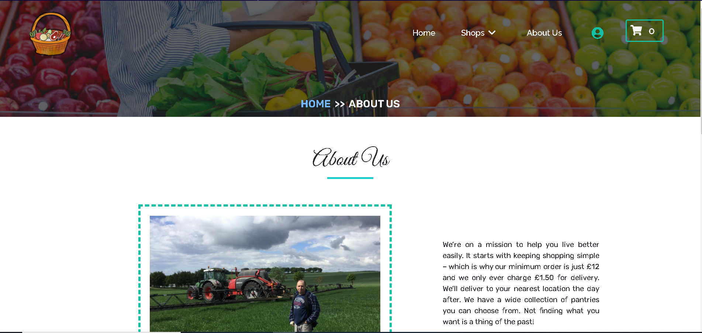

* If customer want to update their profile, they can do it as shown below

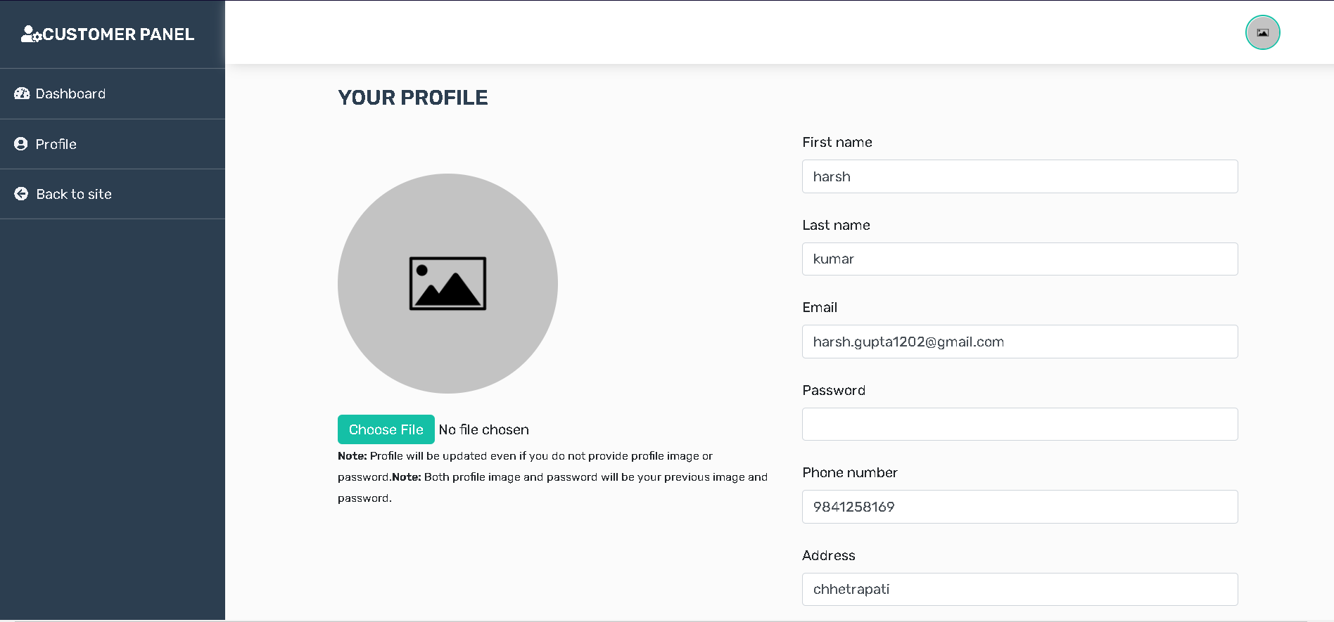

* User Dashboard where they can see the list of products ordered

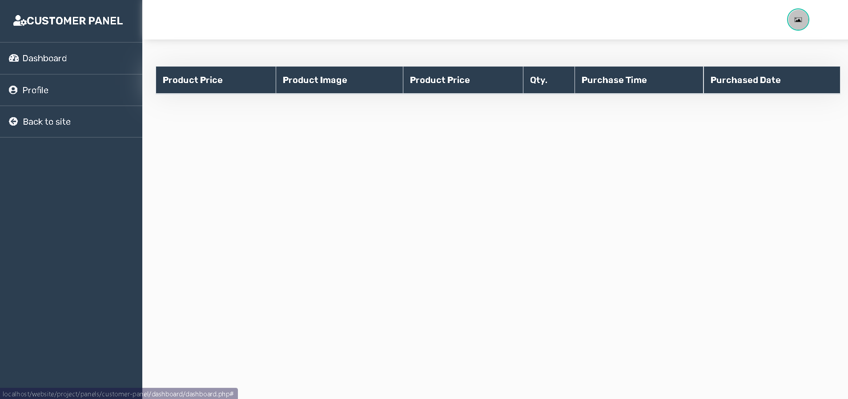

* You can look at the frequently asked question by scrolling down on the homepage to **Frequently Asked Question** section.

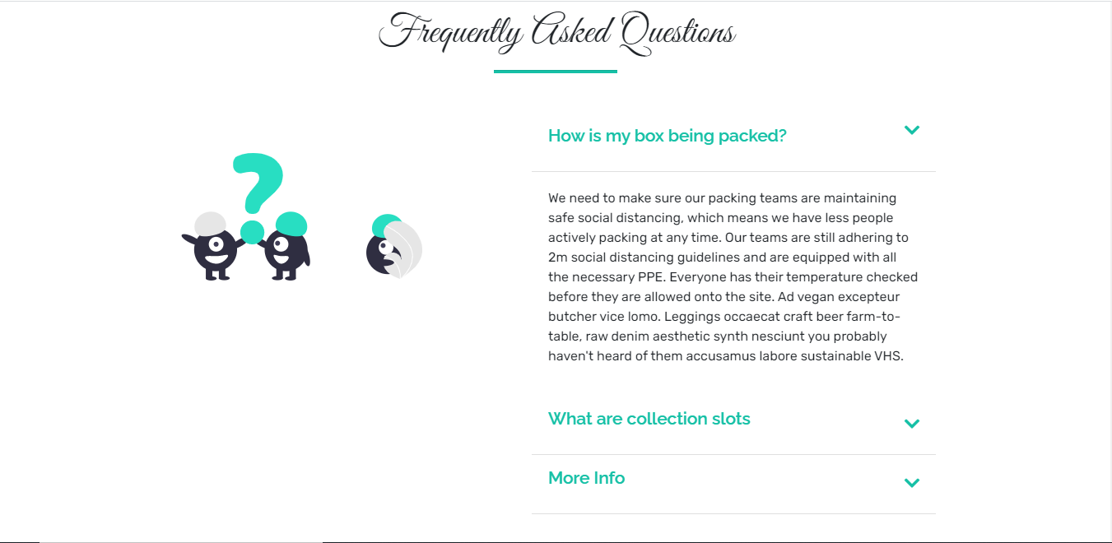

* You search for a specific product directly from the **search bar** but in order to do so you have to first access any one of the five trader shops which can be done by clicking the **Shops** drop down menu

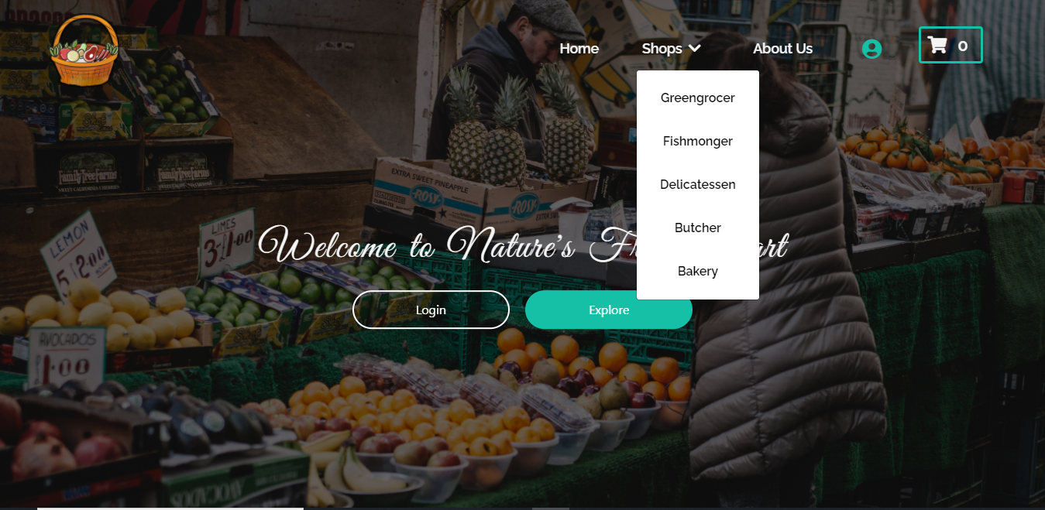

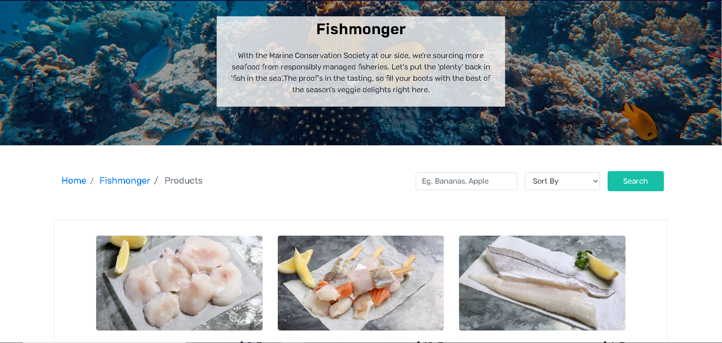

* If you want to view products details ,click on the **View Product** button

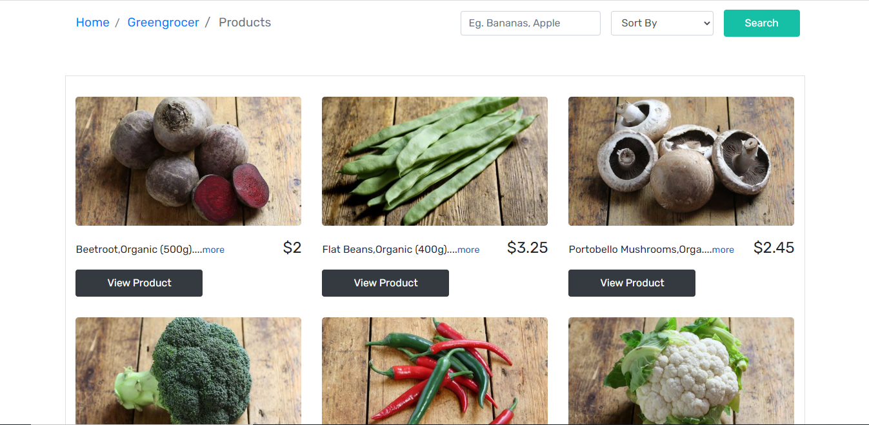

* Sorting the products and Searching Products can be done easily as shown below

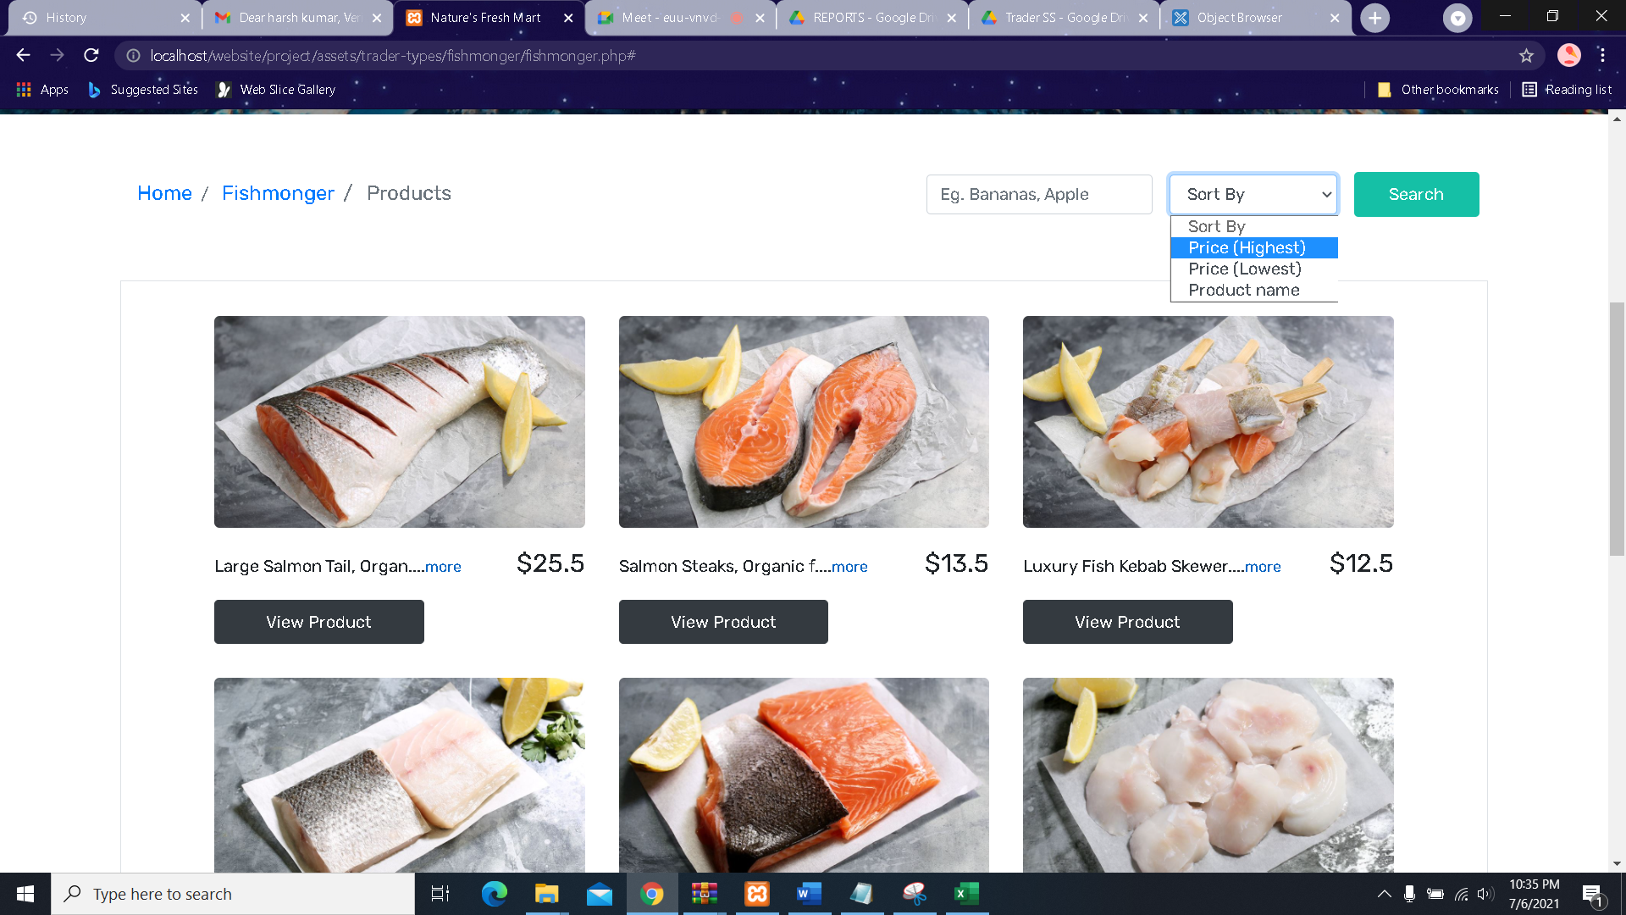

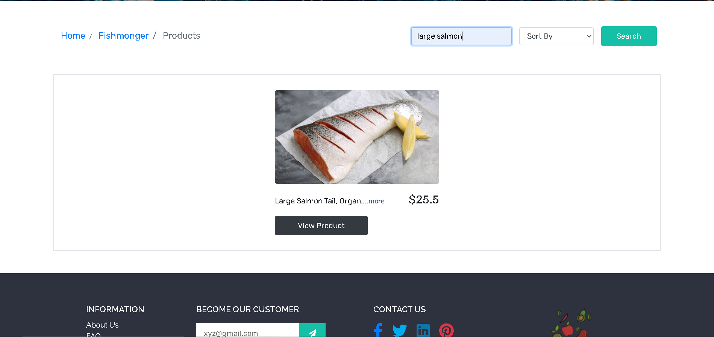

* After logging in you can leave **Reviews** on any product.

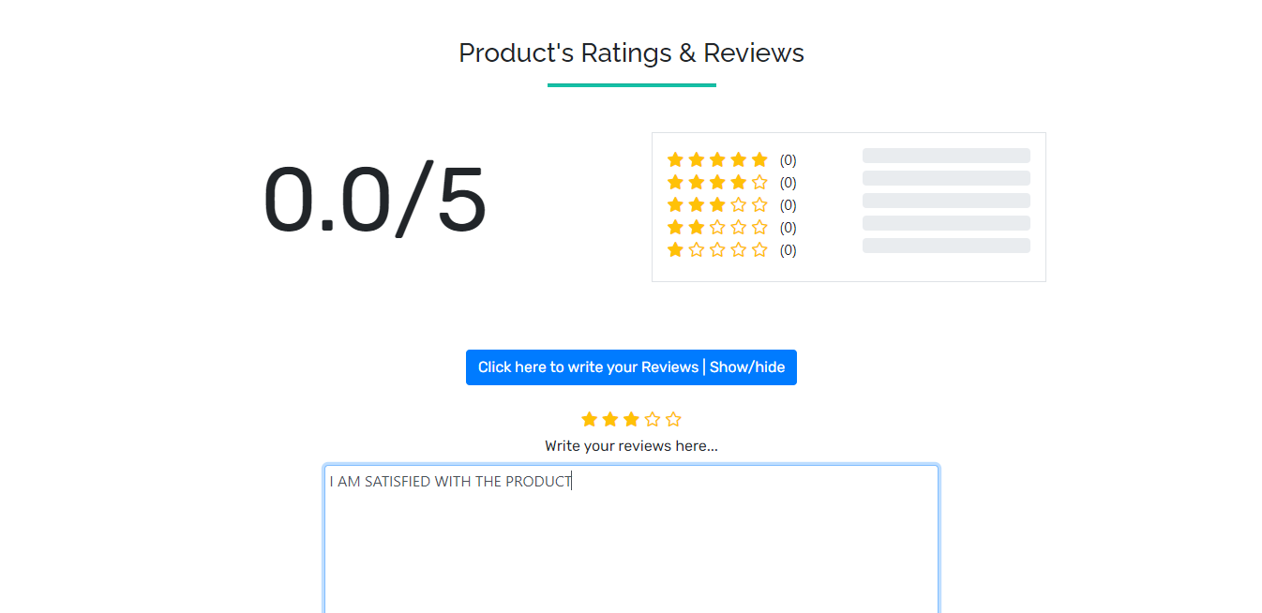

* After clicking the **View Product** button, if you want to add items to the cart then click **on ADD TO CART** button.

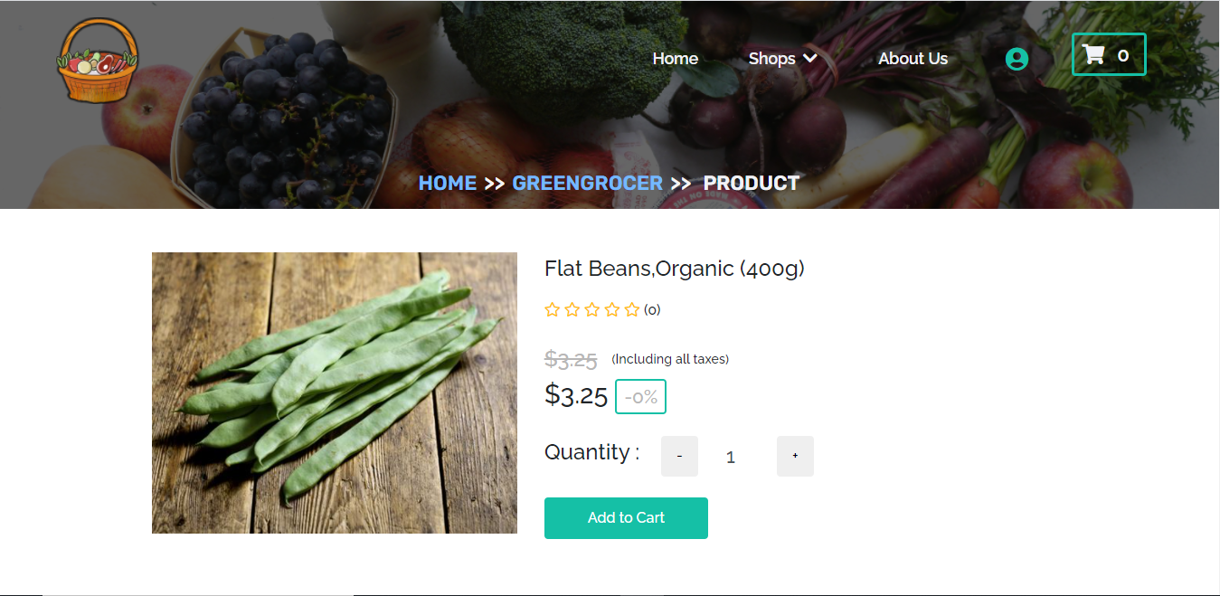

* When you add items to the cart, the items will appear in the **Cart** page. After adding items to the cart you can pay for your items by clicking the **Checkout** button

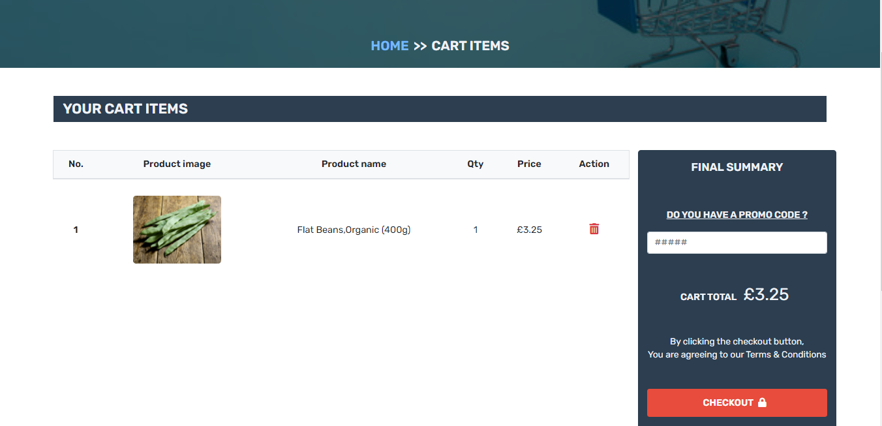

* After clicking the **Checkout** button, you will be directed to a new page where you can choose the **Time Slot** and save your preference by clicking the **Save** button, after that you can pay for your items by clicking the **PayPal** button

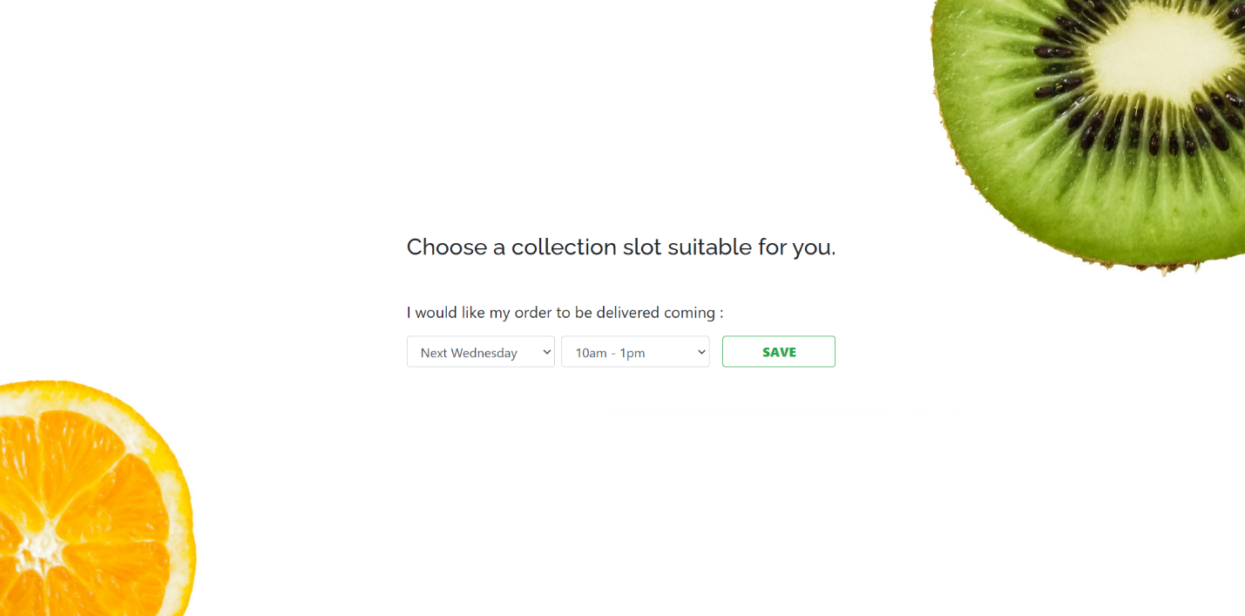

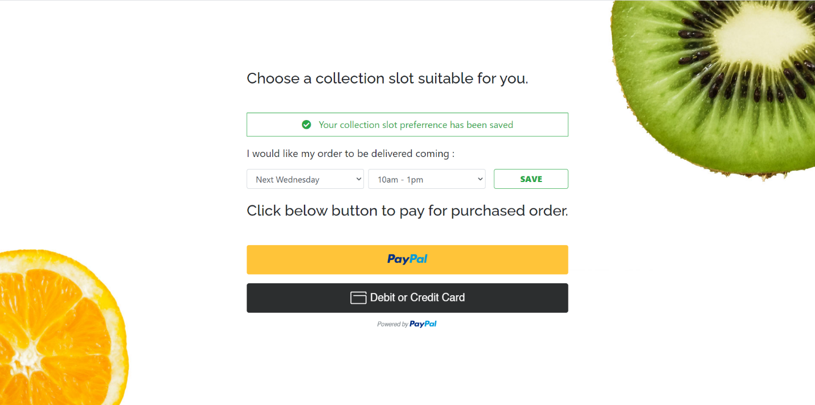

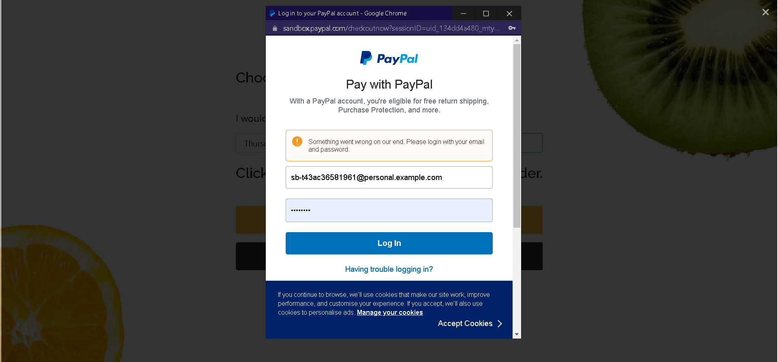

* After payment is successful, customer is redirected to homepage and alert message is displayed and receipt is received in the mail

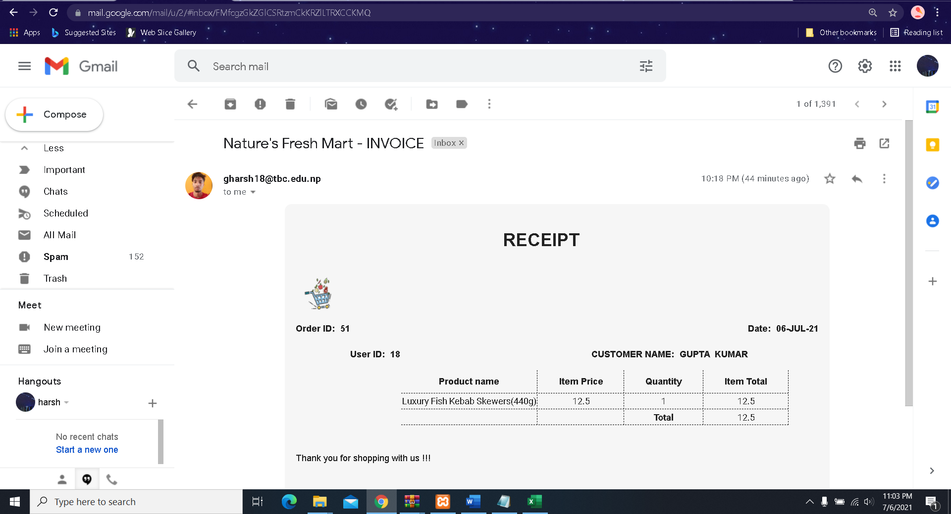

* You can also view your purchase history in the **Dashboard** inside customer panel

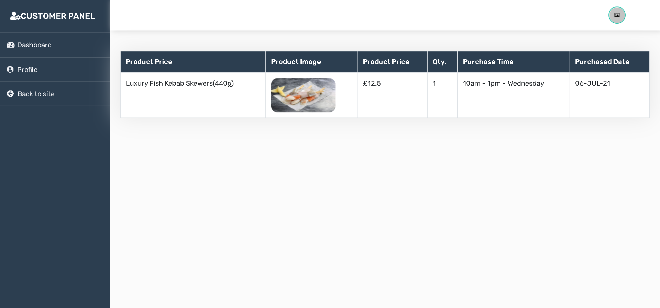

**FOR UNREGISTERED CUSTOMER**

They are able to access everything like view product, add to cart

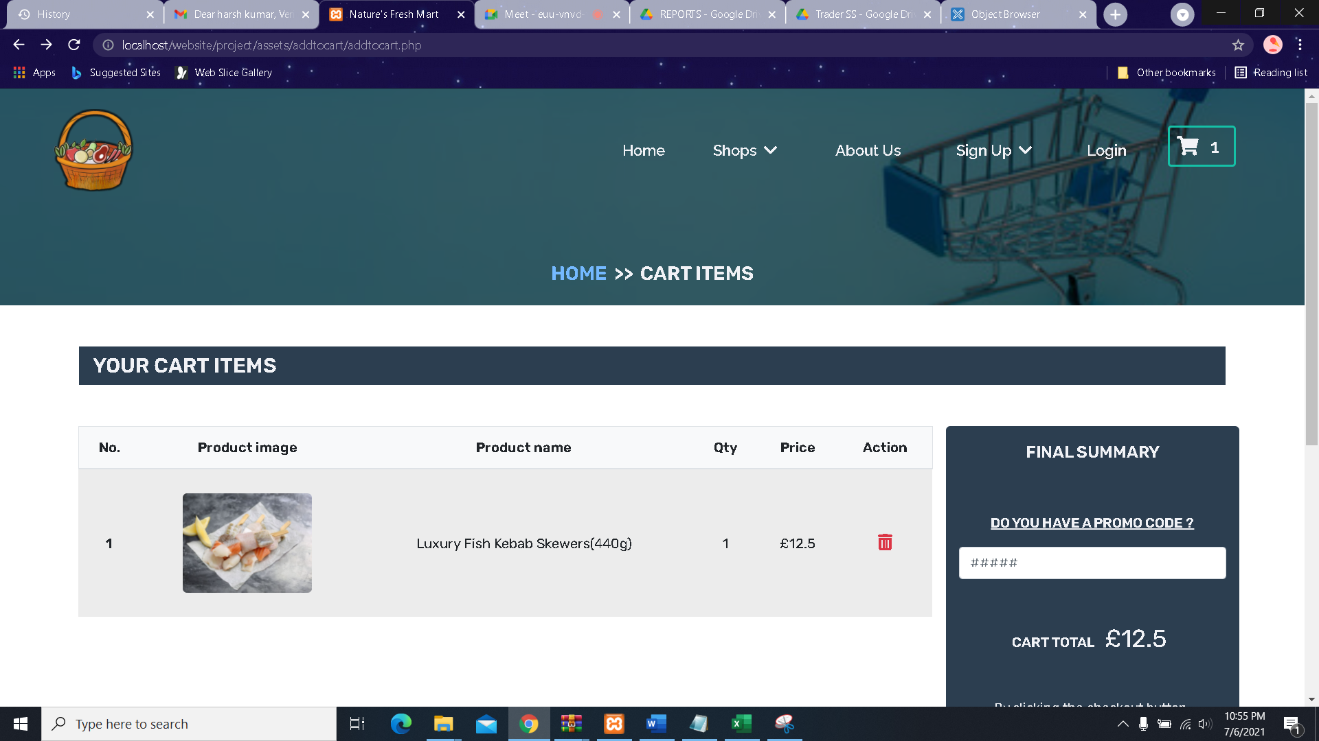

But after checkout is pressed, they will be directed to login page

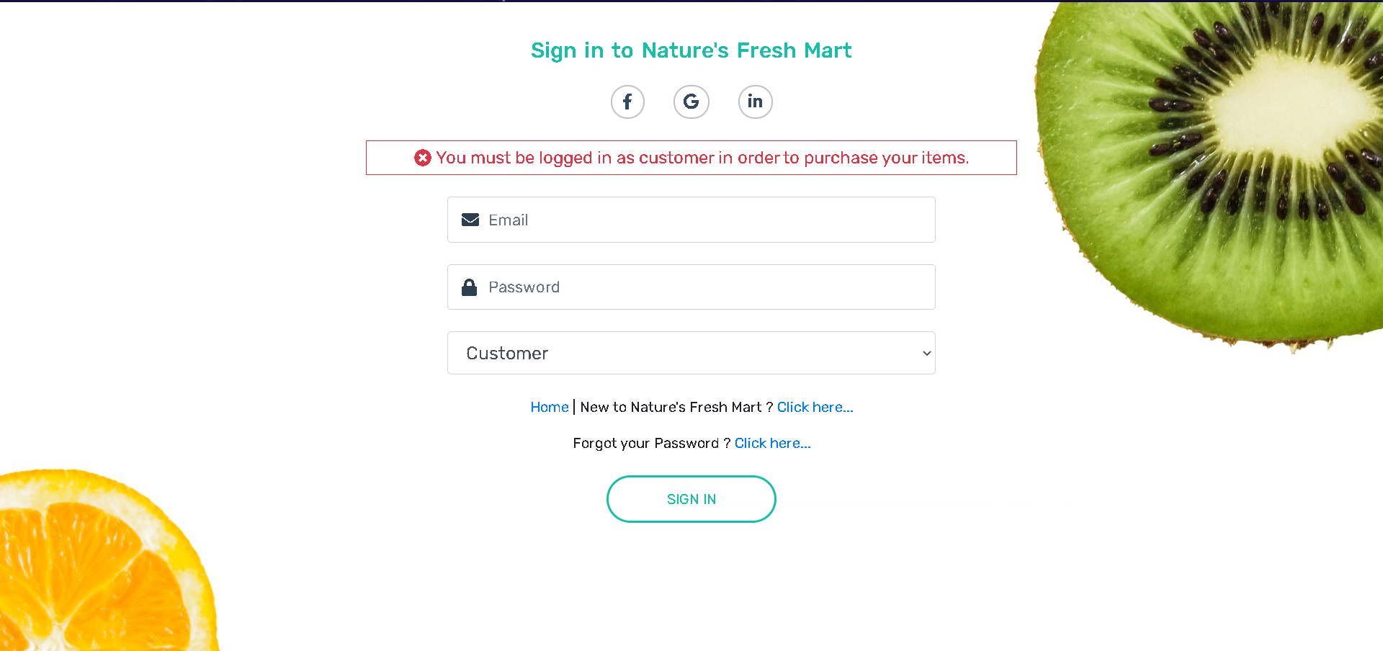

Redirected to homepage after successful purchase and logout is pressed

